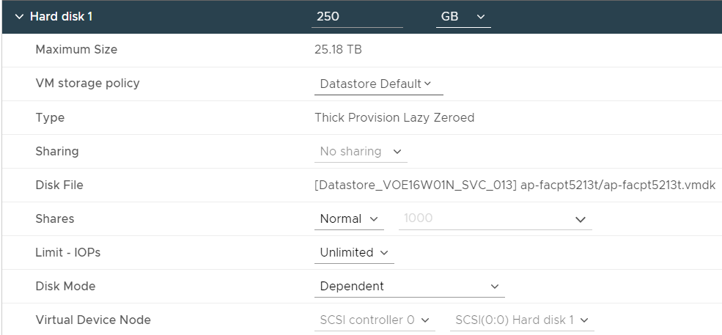

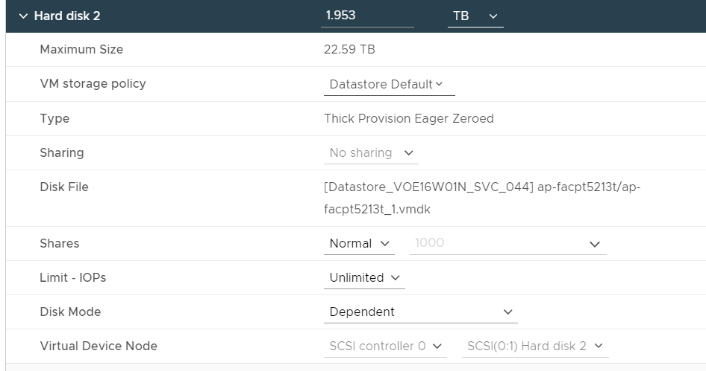



|  |  |  |
| --- | --- | --- |
|  | **LVM disk migration plan for server ap-facpt5213t.** |  |
| **Steps** | **Description** | **Ownership** |
| 1 | Add new disk on server ap-facpt5213t with same size of old disk sdb. | Abhay |
| 2 | Create PV of new disk sdc. | Omprakash |
| 3 | Extend the Volume group facpvg in server by the new PV size. | Omprakash |
| 4 | Need to move the old PV sdb by help of PV move command. | Omprakash |
| 5 | Once the pv is moved we need to insure the complete data is copied, to reduce the vg size facpvg. | Omprakash |
| 6 | Once vg reduce we need to remove the pv as well by pvremove sdb. | Omprakash |
| 7 | If all the steps are done successfully then we need to take a clean reboot before migration. | Omprakash |

Sinha, Manoj Gobikannan, Senthil Barathi Saxena, Abhay

I find a alternate solution to get rid of second disk on server...

|  |
| --- |
| Note : We at least required 2 to 3 hours of filesystem downtime because the 570Gb data copied speed depend on n no. of variables. |

39  2024/11/07 14:24:17 :: lvs  
  140  2024/11/07 14:27:07 :: lsscsi  
  141  2024/11/07 14:27:10 :: lsscsi  
  142  2024/11/07 14:27:12 :: lsscsi -s

To see the underline Pvs’s –

  143  2024/11/07 14:40:28 :: pvs -o+pv_used  
  144  2024/11/07 14:52:56 :: lsssci  
  145  2024/11/07 14:53:00 :: lsscsi -s  
  146  2024/11/07 14:53:53 :: pvcreate /dev/sdc  
  147  2024/11/07 14:54:03 :: vgs  
  148  2024/11/07 14:54:34 :: vgextend facpvg /dev/sdc {for pv free from any LVM}  
  149  2024/11/07 14:54:36 :: vgs  
  150  2024/11/07 14:54:43 :: pvs  
  151  2024/11/07 14:55:19 :: history  
  152  2024/11/07 14:55:38 :: pvs -o+pv_used  
  153  2024/11/07 14:55:56 :: vgs  
  154  2024/11/07 14:56:18 :: pvs -o+pv_used  
  155  2024/11/07 14:56:31 :: pvmove /dev/sdb  
  156  2024/11/07 15:16:07 :: pvs -o+pv_used  
  157  2024/11/07 15:16:18 :: pvs -o+pv_used  
  158  2024/11/07 15:16:21 :: vgs

So that we can remove the pv from **/dev/sdb(issue Disk)**  
  159  2024/11/07 15:18:24 :: vgreduce facpvg /dev/sdb {So that after reboot it will not search data in previous disk}  
  160  2024/11/07 15:18:29 :: vgs  
  161  2024/11/07 15:18:48 :: pvs  
  162  2024/11/07 15:19:04 :: df -hPT

Checking is everything ok after reducing(removing) facpvg--

  163  2024/11/07 15:19:21 :: cd /data/facp  
  164  2024/11/07 15:19:25 :: touch hello  
  165  2024/11/07 15:19:29 :: rm hello  
  166  2024/11/07 15:19:50 :: cd  
  167  2024/11/07 15:19:52 :: vgs  
  168  2024/11/07 15:19:54 :: pvs  
  169  2024/11/07 15:20:05 :: pvs -o+pv_used  
  170  2024/11/07 15:20:53 :: pvremove /dev/sdb  
  171  2024/11/07 15:20:56 :: pvs  
  172  2024/11/07 15:20:59 :: vgs  
  173  2024/11/07 15:21:14 :: lsscsi  
  174  2024/11/07 15:21:17 :: lsscsi -s  
  175  2024/11/07 15:21:22 :: mount -a  
  176  2024/11/07 15:21:25 :: df -hPT  
  177  2024/11/07 15:21:52 :: lsblk /dev/sdc  
  178  2024/11/07 15:22:03 :: cd /var/facp  
  179  2024/11/07 15:22:04 :: ls  
  180  2024/11/07 15:22:12 :: touch hello  
  181  2024/11/07 15:22:19 :: vgs  
  182  2024/11/07 15:22:26 :: ll  
  183  2024/11/07 15:22:30 :: rm hello

Disk checking --

  184  2024/11/07 15:22:43 :: lsscsi -s  
  185  2024/11/07 15:24:45 :: lsscsi -s  
  186  2024/11/07 15:26:37 :: mount -a  
  187  2024/11/07 15:26:39 :: df -hPT  
  188  2024/11/07 15:28:18 :: lsscsi -s  
  189  2024/11/07 15:28:21 :: mount -a